Justin Hartwell 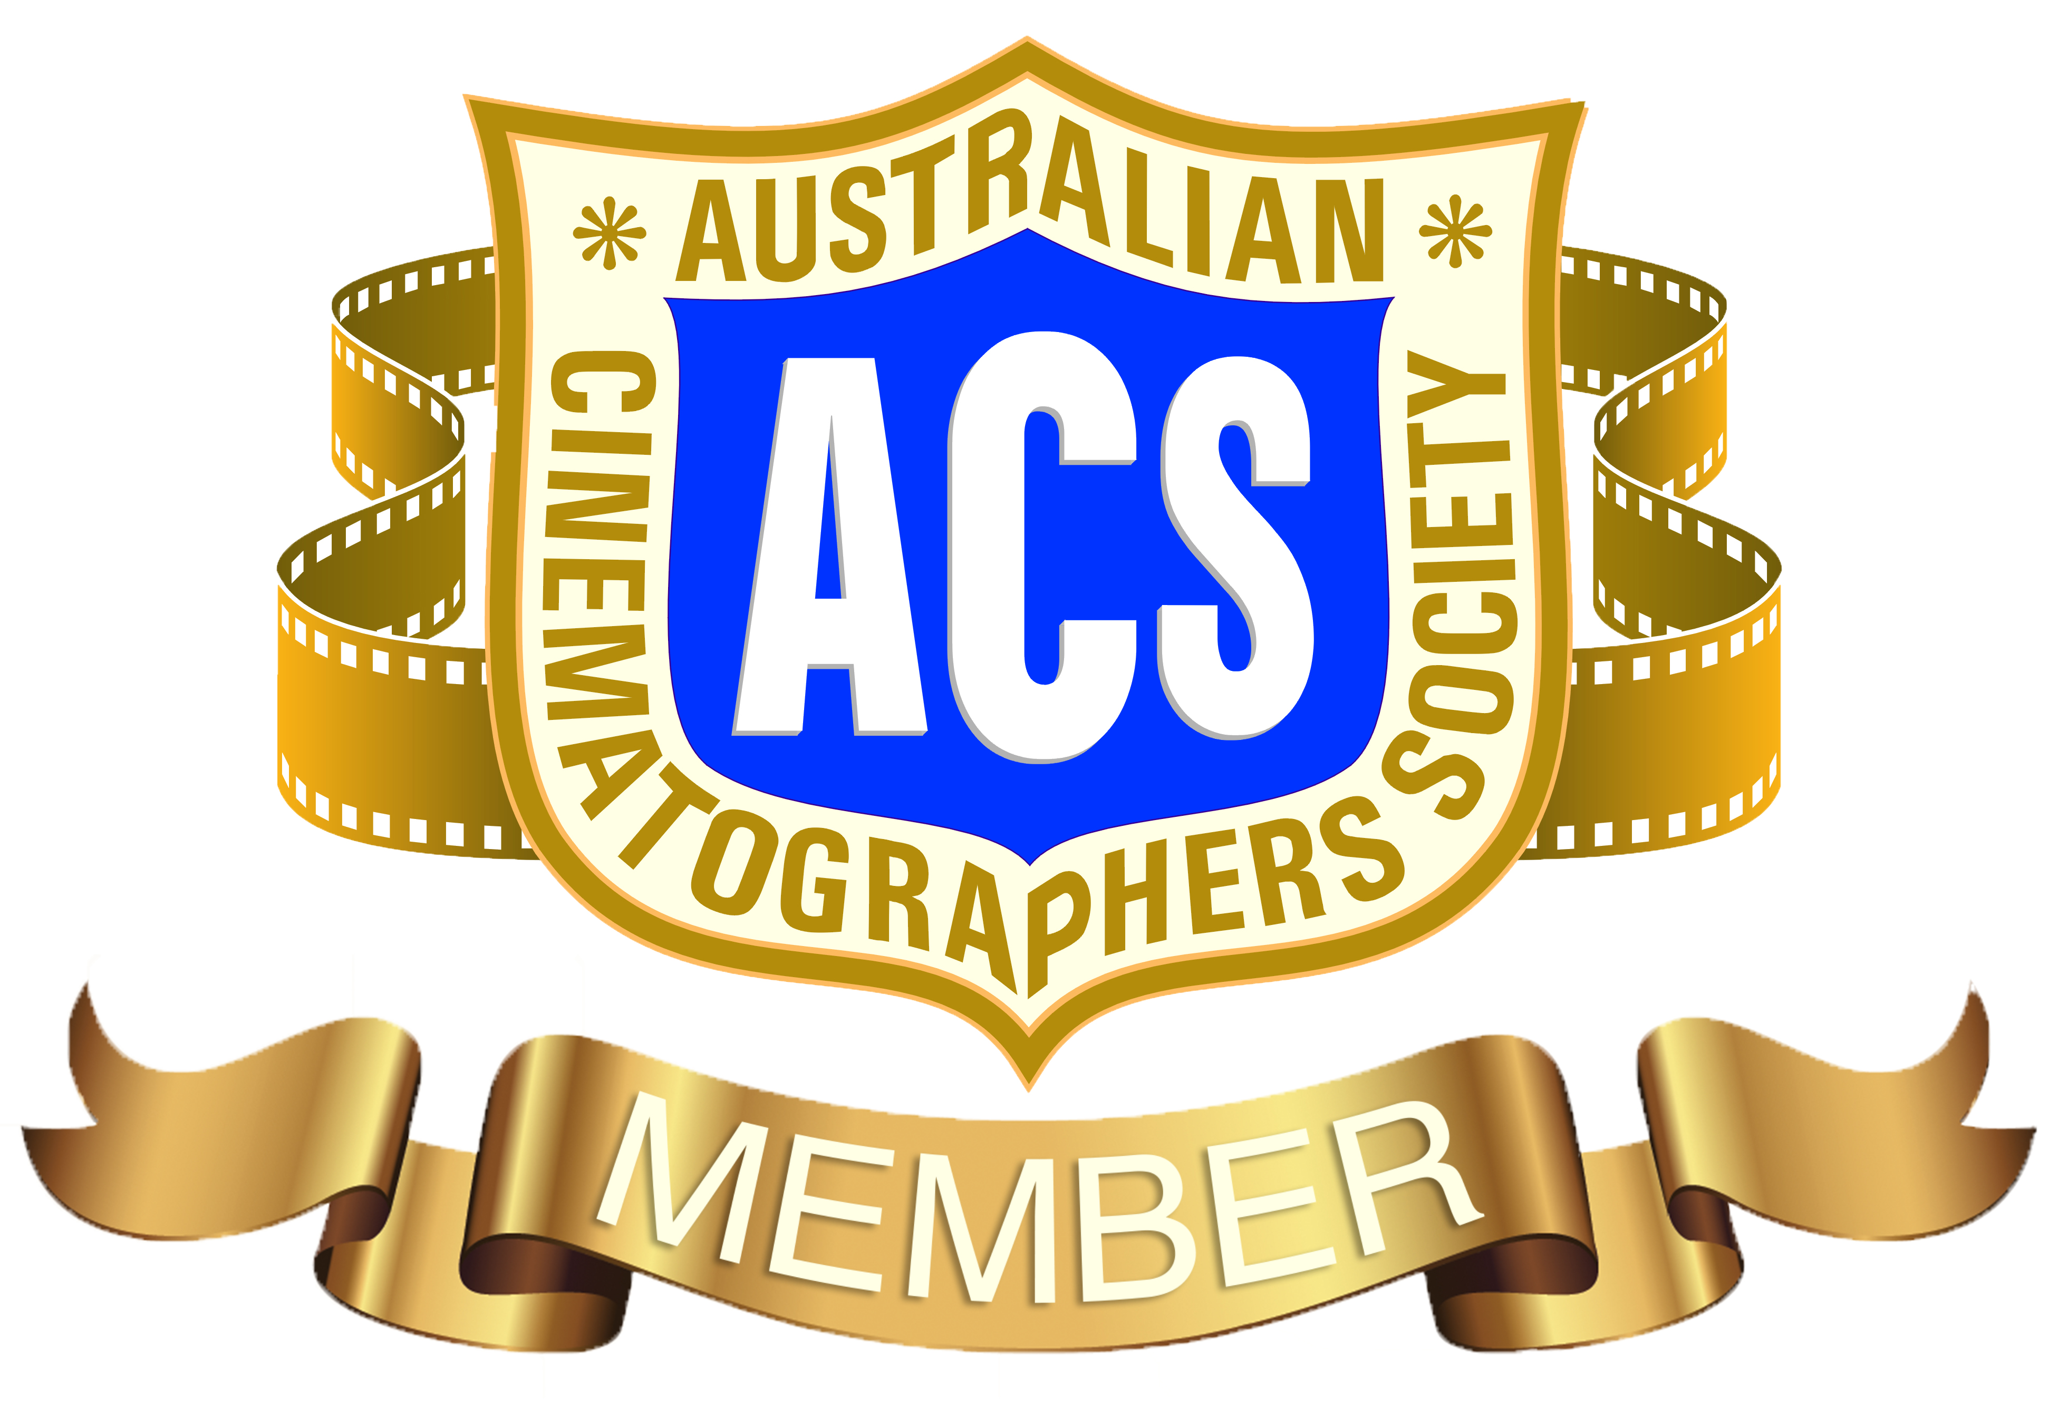
Justinhartwellcinema@gmail.com
0412 531 993

Camera Department
CAMERA OPERATOR

DRAMA

ROCK ISLAND MYSTERIES S1 & S2 (TV Series) B Camera Operator (Additional) SONY VENICE 1 DOP: Andrew Conder SOC ACS 0411 260 476
Director: Jovita O’Shaughnessy 0419 261 039

THE BUREAU OF MAGICAL THINGS S2 (TV Series) B Camera Operator (Additional) ARRI ALEXA DOP: Andrew Conder SOC ACS

REEF BREAK (TV Series) 2nd Unit B Camera Operator (Additional) SONY VENICE
DOP: Andrew Conder SOC ACS

AN UNCONVENTIONAL LOVE (Short) B Camera Operator Canon C100
DOP: Andrew Conder SOC ACS

BROADCAST

Muai Thai Grand Slam 7 (Live Event, Ringside Camera)
Producer: Brian Kirwan 0418 960 972 Director: Andrew Hollamby 0439 720 260

2023 IBO World Title Fight (Live Event, Ringside Camera)
Producer: Brian Kirwan Director: Andrew Hollamby

BEATDOWN MMA (Live Event, Ringside Camera)
Producer: Brian Kirwan Director: Andrew Hollamby

MURRI V KURRI INTERSTATE CHALLENGE (Live Rugby League Event)
Producer: Brian Kirwan Director: Andrew Hollamby

CH7 XXI COMMONWEALTH GAMES (Track & Field).
Unit Manager: Bernadette Smith 0408 500 320

CORPORATE

BRISBANE GIRLS GRAMMAR SCHOOOL 2020 Concert Video B/C Camera Operator Panasonic Eva1 DOP / Director: Simon Woods 0404 827 090 simonwoods3@me.com

2019 QLD & NT ACS Awards –Panasonic Varicam – QLD President: Erika Addis eaddis@cinematographer.net.au

2018 QLD & NT ACS Awards –Sony FS5 – QLD President: Erika Addis
CAMERA OPERATOR – Cont’d

THE OJI CUP WRAP – A Camera
Producer: Sarah Robinson

WORLD HEALTH ORGANISATION CONFERENCE
DOP: Trevor Brazil 0401 740 261

CINEMATOGRAPHER + CAMERA OPERATOR

DRAMA

NANA’S FOOTSTEPS (Web series) Producer: Madison Marneros 0487 884 096

EFFIGY (Short)
Director: Connor Oscar Clarke 0422 895 103 connor_clarke@hotmail.com
2021 Bronze Award – Short Films

LAND OF THE FREE (Documentary) Lynn Santer Interview
Producer: Lynn Santer lynn.santer@yahoo.com

THE LAST ZOMBIE (Short) Director: John Walton 0411 844 844 thestuntfarm@yahoo.com

YOU’RE GONE (Short) Director: Anthony Miller 0448 999 962 mad.antz.films@hotmail.com

BLOODLINE (Short) Director: Madison Marneros 0487 884 096

B&E (Short) Director: Anthony Miller

HOW TO SURVIVE THE APOCALYPSE WITH STYLE (Pitch Pilot)
Producer: Susan Austin: 0404 850 000

BEAUTIFUL SCARS (Short) Director: Linda Marie Curry 0427 333 991

NICKED (Short) Director: Anthony Miller

HANK & LUNA (Short) Director: Verity Grace

ONLY THE NIGHT (Short) Director: Anthony Miller

MUSIC VIDEOS

DARREN JOHNSON “Where You Are” Producer: Dorothy Daisy 0447 779 340

CASSIE TIMMS “Chasing Summer” Director: Dan Jensen 0403 738 269

ETERNAL TORMENT “Depose The Elite” Director: Dan Jensen

BUFFY PRESCOTT “Know The Score” Director: Dan Jensen

CINEMATOGRAPHER + CAMERA OPERATOR (Cont’d)

BROADCAST

CATAPAULT HOMES “Builders Grant” Campaign (TVC)
Director: Sarah Robinson sarah@thevideobox.com.au 0402 377 112

NOVA / GOLDEN CIRCLE “Get Out Camp Out” (TVC)
Producer: Darren McLeod 0438 220 083 dmcleod@novaentertainment.com.au

GO BOWLING ASHMORE / TWEED HEADS (TVC)
Producer: Melissa Hankin mel@hankinmedia.com.au 0404 117 047

CORPORATE

ORIGIN ENERGY – ELT Safety Month
Producer: Shannon Swan – Resolution Media shannon@resolutionmedia.tv
0401 077 402

APOLLO JACKSON “With You” (Music Video - BTS)
Director: Shannon Robinson 0416816177

MAIN STREET FESTIVAL, RIPLEY TOWN CENTRE
Producer: Sarah Robinson

DATA WRANGLER

DRAMA

LOVELAND (Feature) ARRI ALEXA MINI. 1st AC: Brendan Issac 0407 123 031

CAMERA ASSIST

BROADCAST

CH 9 2019 TV WEEK LOGIE AWARDS. Darren Lynch 0419 018 664

CH 9 2018 TV WEEK LOGIE AWARDS. Bernadette Smith 0408 500 320

CH7 XXI COMMONWEALTH GAMES – Steadicam Assist, Opening & Closing Ceremony. Warren Tiedgen 0412 589 999 criticalmassmedia@hotmail.com

GRIPS

DRAMA

DORA & THE LOST CITY OF GOLD (Feature) Additional. Best Boy: Billy Harmer 0407 123 031 billysgrip@gmail.com

BROADCAST

CH7 AUSTRALIAN SWIMMING TRIALS. Steve Issac ACS 0418 728 324

